CS Notes 5-28

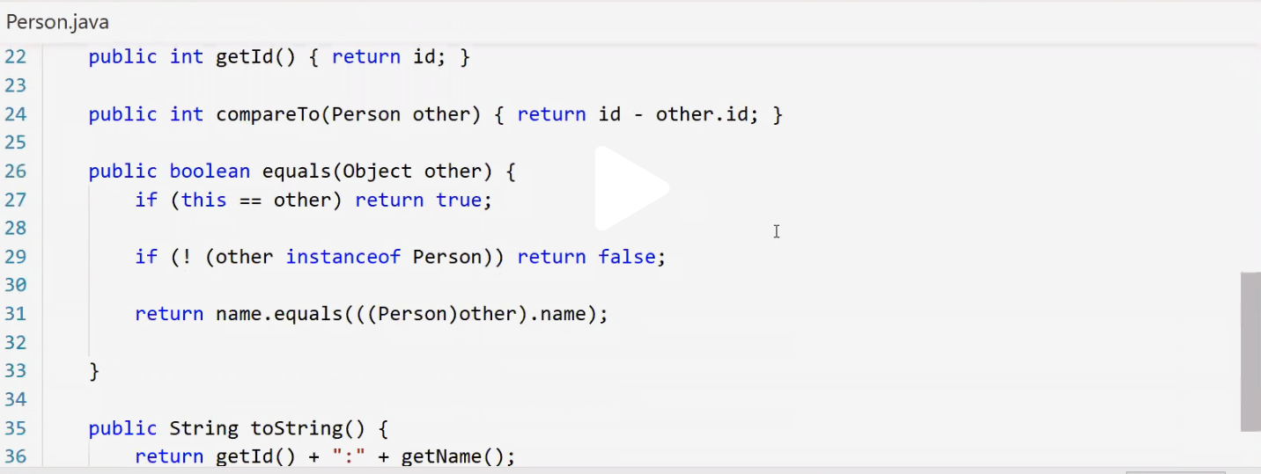

If I had a linked list and wrote a traditional for loop

For(int I = o; i<list.size();i++){

System.out.println(list.get(i));

You must have an interator (iterable) to do a for each loop

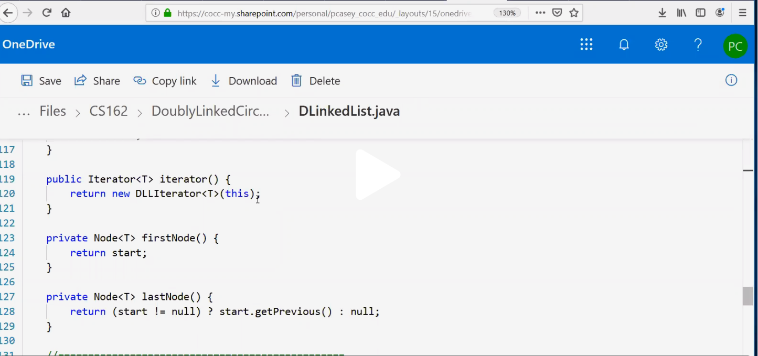

Exceptions

Pointing to memeory vs pointing to variables will be on the final

Quick sort will be o nthe final